**Sales Funnel Analysis - Entertainment Sector**

Pooja Joshi & E.Code [E25007]

# Overview :

# The goal of today's task was to perform data visualization on the Sales Funnel Summary generated from the dataset containing movie-related information, focusing on key funnel stages like Awareness, Interest, Consideration, and Action. The visuals would help in understanding the funnel's performance for a given set of movies, particularly "Avatar: The Way of Water."

# Objective:

The objective was to create effective visualizations for the Sales Funnel Summary and analyze key stages such as Awareness (popularity), Interest (ratings), Consideration (sentiment), and Action (attendance) based on the given dataset.

# Assigned Task(s) :

·· Perform visualization for **Sales Funnel Summary**.

· Generate bar charts for the **Top 5 movies** in the Interest, Consideration, and Action stages.

· Incorporate **relevant metrics** in visual formats (e.g., bar charts).

# Task Details :

### Task 1: Sales Funnel Summary Visualization

* **Status**: Completed
* **Details**:  
  The Sales Funnel Summary was visualized, focusing on key metrics like popularity, vote average, sentiment, and attendance. Visualizations included bar plots for each funnel stage, illustrating how the movie "Avatar: The Way of Water" performed across the stages.

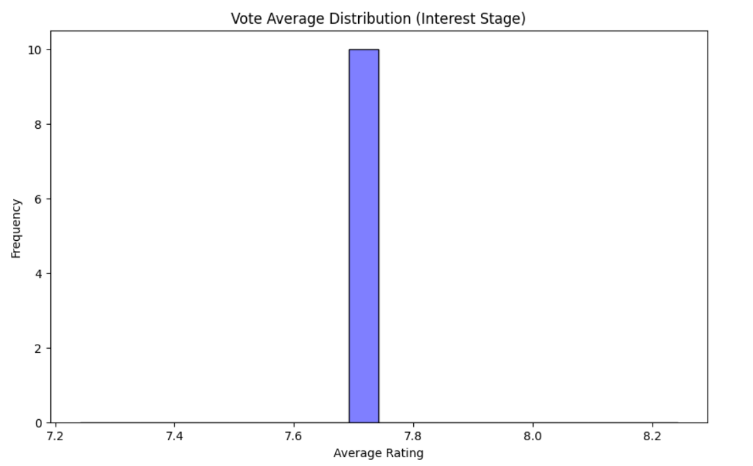

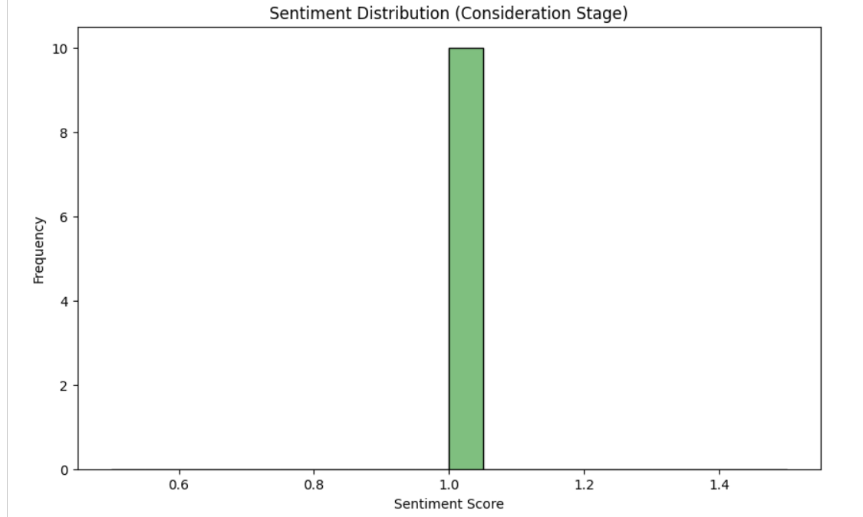

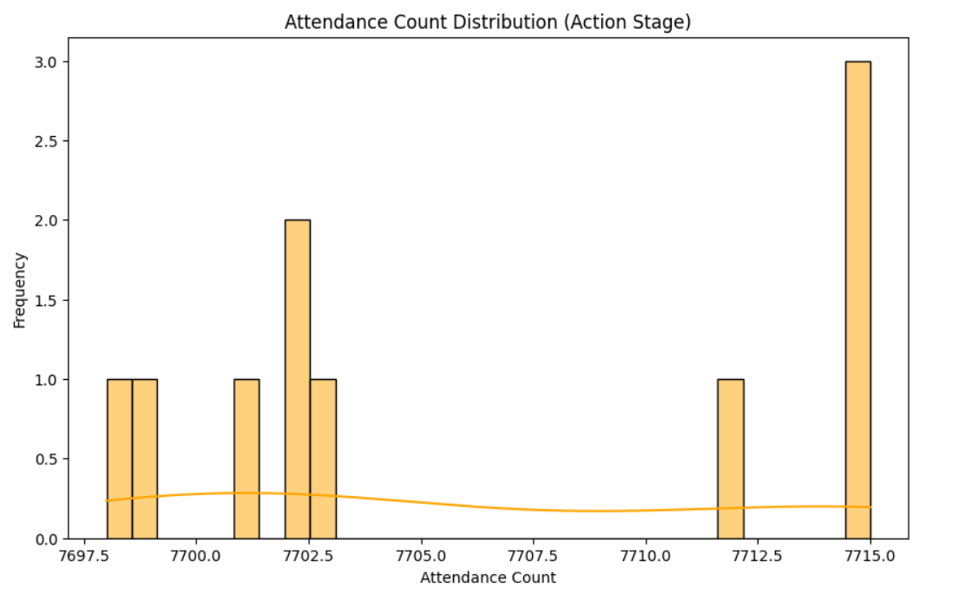

### Task 2: Viewer Behavior Modeling Analysis

* **Status**: Completed
* **Details**:  
  Performed analysis on the **Viewer Behavior Modeling** dataset. Key insights include:
  + Relationship between **valuation** and **attendance**: Movies with higher valuations tend to have greater attendance, demonstrating a strong **correlation** between these two variables.
  + **Sentiment vs. Vote Average**: Movies with positive sentiment generally had higher vote averages, showing that positive audience feedback aligns with higher ratings.

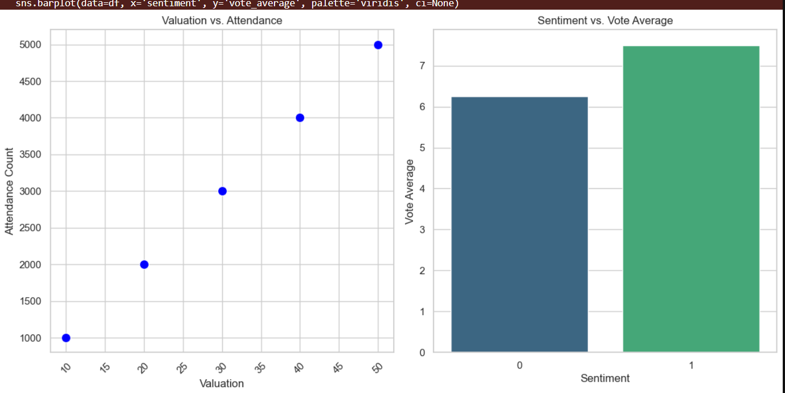

### Task 3: Trend Identification between Valuation and Attendance

* **Status**: Completed
* **Details**:  
  Used scatter plots to visualize the trend between **valuation** and **attendance_count**. The trendline showed that higher-valued movies attracted larger audiences, with some outliers performing exceptionally well in attendance despite moderate valuation.

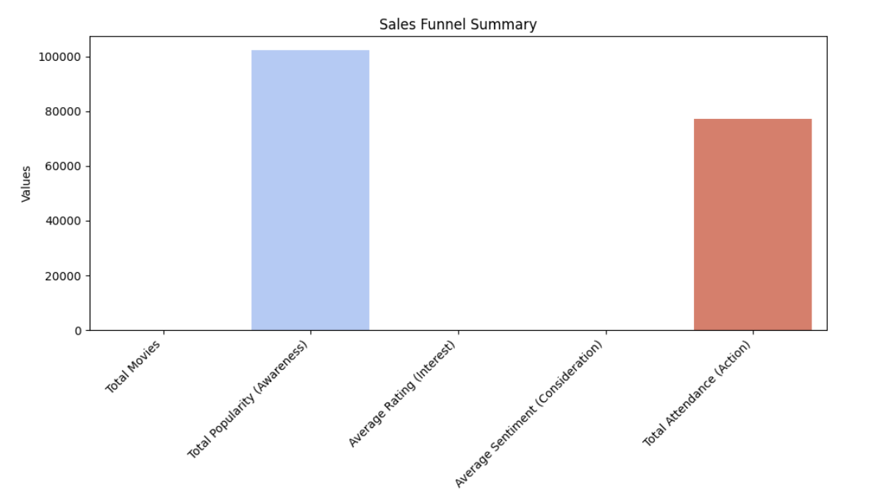

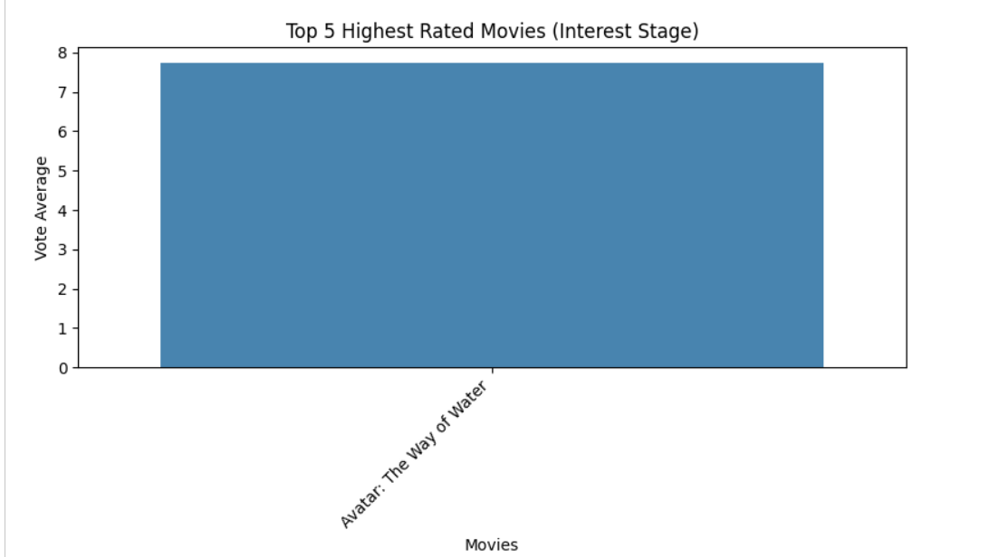

### Task 4: Sentiment and Vote Average Comparison

* **Status**: Completed
* **Details**:  
  A comparative analysis was performed between **sentiment** and **vote_average** using box plots. It was observed that movies with positive sentiment had a narrower range of vote averages, often leaning towards higher ratings.

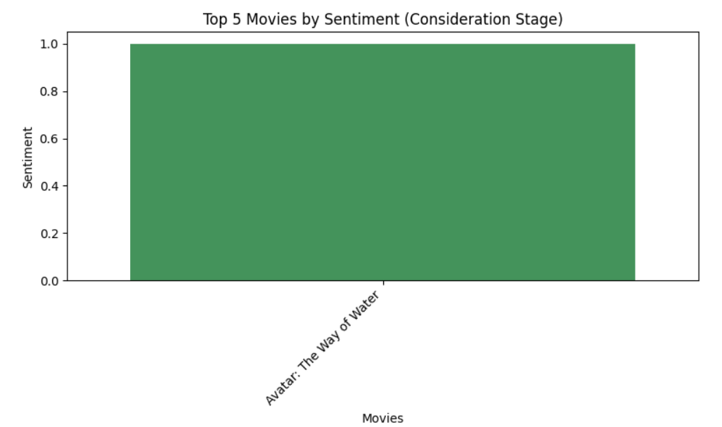

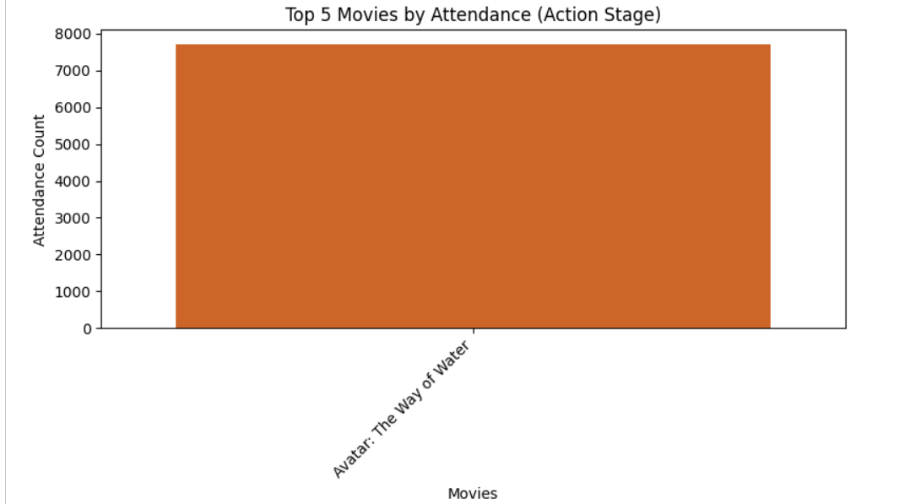

**Progress :**

**Accomplishments**:

* + Completed **Sales Funnel Summary** visualizations for top-performing movies.
  + Successfully identified key trends in **Viewer Behavior Modeling**, focusing on valuation-attendance relationships and sentiment-vote average comparisons.

**Metrics**:

* + **Popularity**: 102,242.8 total (Awareness Stage).
  + **Attendance**: 77,062 cumulative (Action Stage).
  + **Vote Average**: 7.742 (Interest Stage for top movie).
  + **Sentiment**: Positive for the top 5 movies.

# Challenges and Solutions :

· **Challenges Faced**:

1. **Binning Errors**: Duplicate bin edges caused issues in popularity categorization during visualization.
2. **Non-Numeric Sentiment Data**: Sentiment data was textual (e.g., "Positive"), causing errors when calculating averages.

· **Solutions Implemented**:

1. Solved the binning issue by using duplicates='drop' to remove duplicate edges when categorizing popularity.
2. Converted textual sentiment data into **numeric values** (1 for "Positive"), which allowed for smoother calculations and visualizations.

# Next Steps :

· **Upcoming Tasks**:

* Deep dive into **genre-specific** viewer behavior.
* Extend the funnel analysis to include post-attendance behaviors like merchandise sales and repeat viewership.

· **Goals**:

* Enhance analysis by incorporating **new data sources** and exploring correlations between **genre, audience demographics**, and **viewer sentiment**.
* Improve visualizations by refining chart types, such as heatmaps for deeper insights into **viewer engagement**.

# Conclusion :

# Summary: This report covers the visualizations created for the Sales Funnel Summary and the analysis performed for the Viewer Behavior Modeling dataset. Key insights into movie performance across funnel stages and viewer engagement trends were generated, particularly for "Avatar: The Way of Water."

# **Acknowledgments**: Thank the audience for their time and attention.

# Instructions:

1. Use Google Docs. Single Column
2. TNR stands for Times New Roman: B - Bold
3. Use images as required with proper references
4. Use charts, tables as per your requirement.
5. Number of Pages: 2 to 8 for each task report.